# Project progress

## Process and idea:

The idea was to develop an interactive map where the user can see some Points of interest (POI) around Paris and his location.

It is very scalable as the data used to geolocalize keypoints is taken from the open data (<https://www.data.gouv.fr/fr/> ), and the code was developed to match this criteria of the simplicity to implement other categories in the future.

Currently, here are the Points of interest available:

- Pharmacies

- Parcs

- Hospitals

- Sports Centers

The goal is also to automatically create a detailed route with a step to the closest POI chosen category.

Here are the global steps to carry out a such project:

* Find an innovative idea
* Search for relevant data in open data
* Data analysis
* Data visualization
* Implementation of routing system (multilevel Dijkstra)
* Synchronizing the routing system with the processed data
* Implementation of speech recognition
* Forward Geocoding the recognized speech to have the coordinates to push to the route

## Demo:

You can choose and select one of those by checking the radio buttons on the top corner right of the screen. Here are some examples: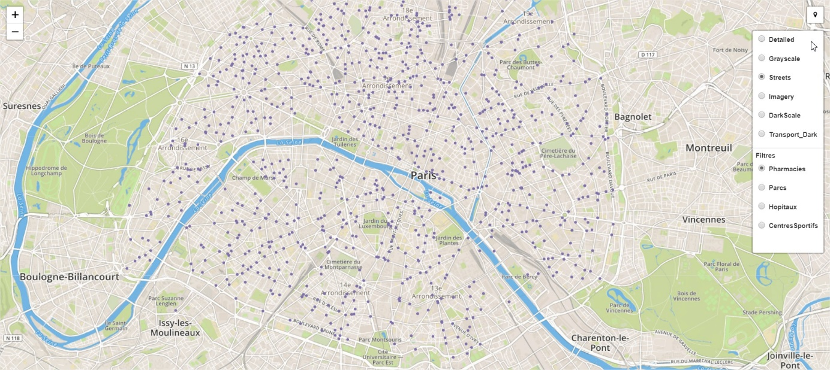

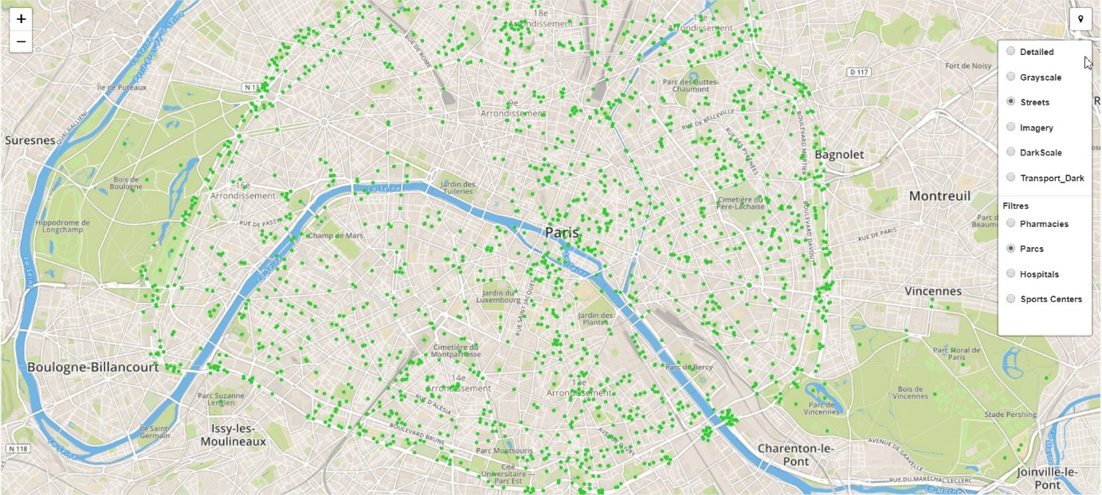

You can Geolocate yourself by pressing the button on the very top right of the screen

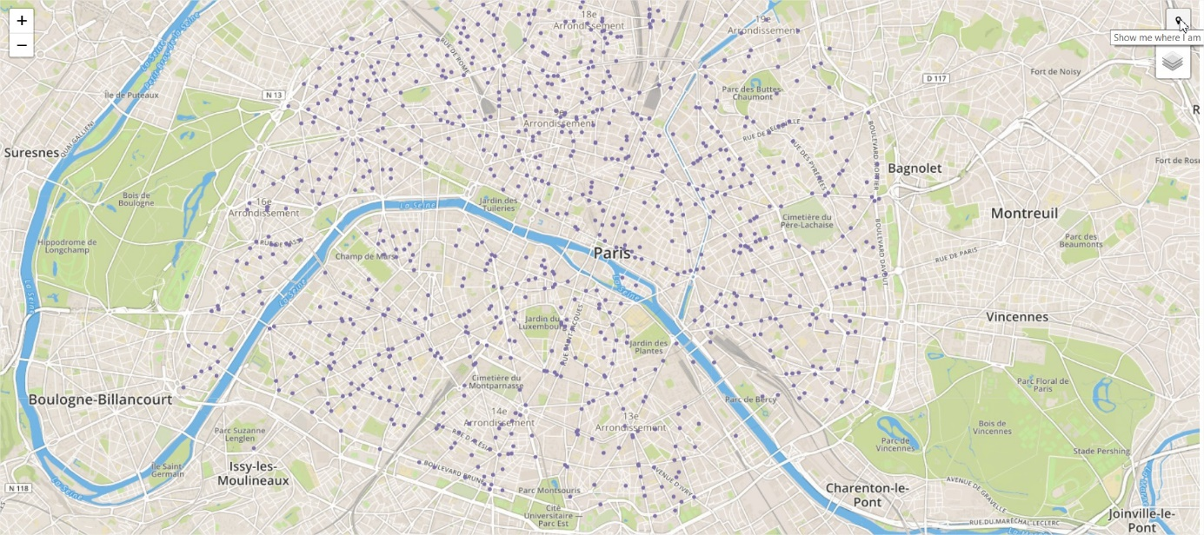

By clicking this button, a route will also be created automatically with a stopover on the nearest POI to the chosen category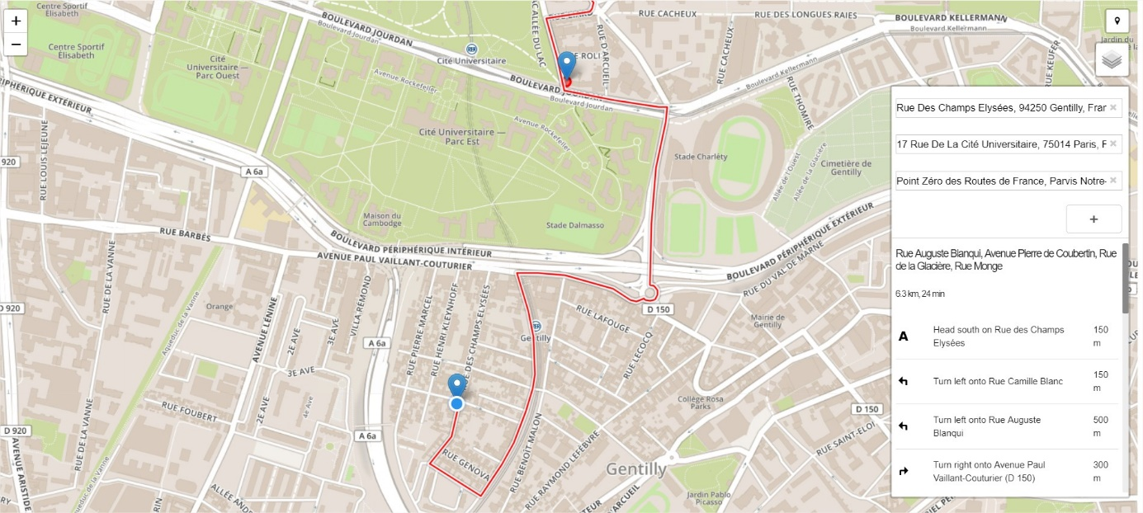

With a specific Geocoder, you can choose the final destination with autocompletion features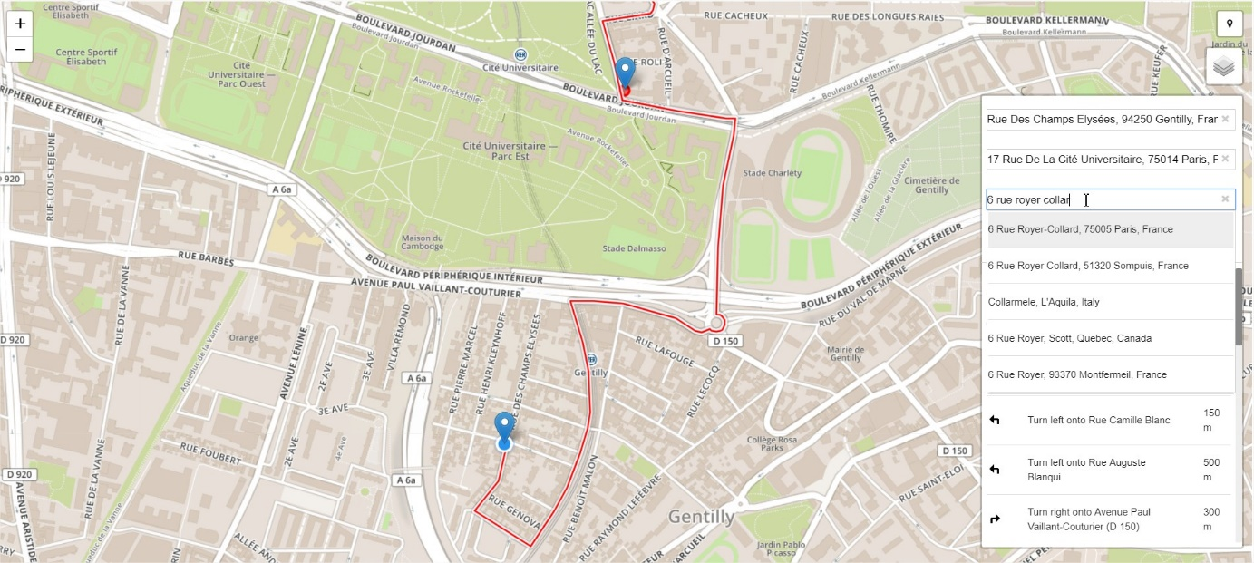

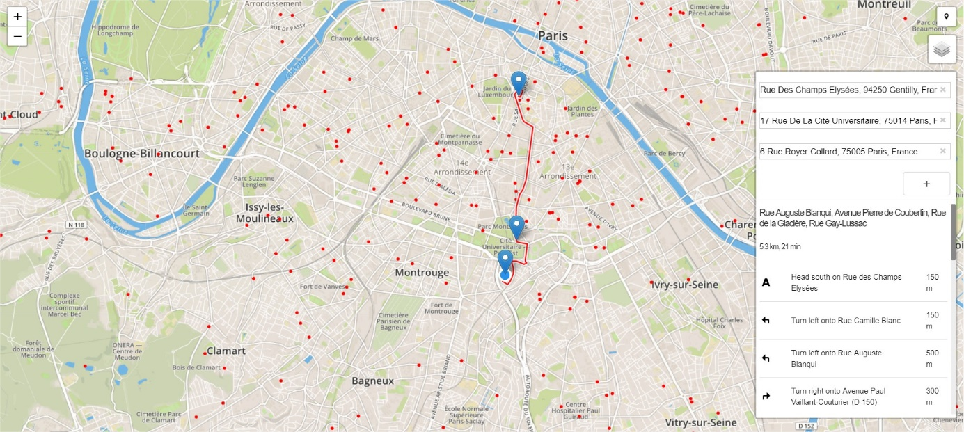

You can customize your route by either drag a point to another location: 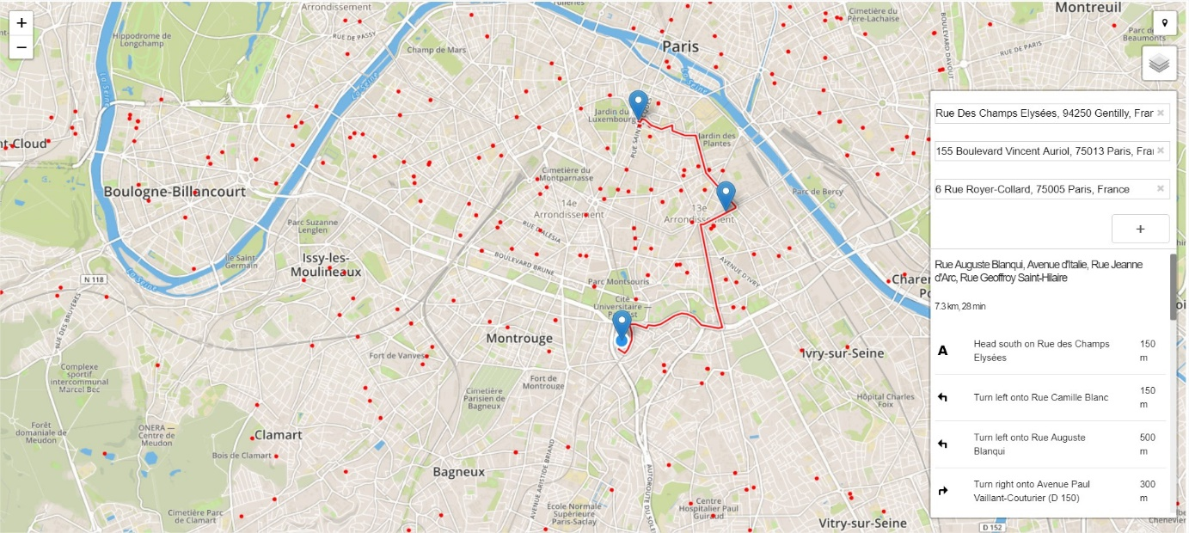

Or adding another step by clicking and dragging on the red route. You can have some details one the route selected by hovering the mouse on the route on the bottom right of the screen:

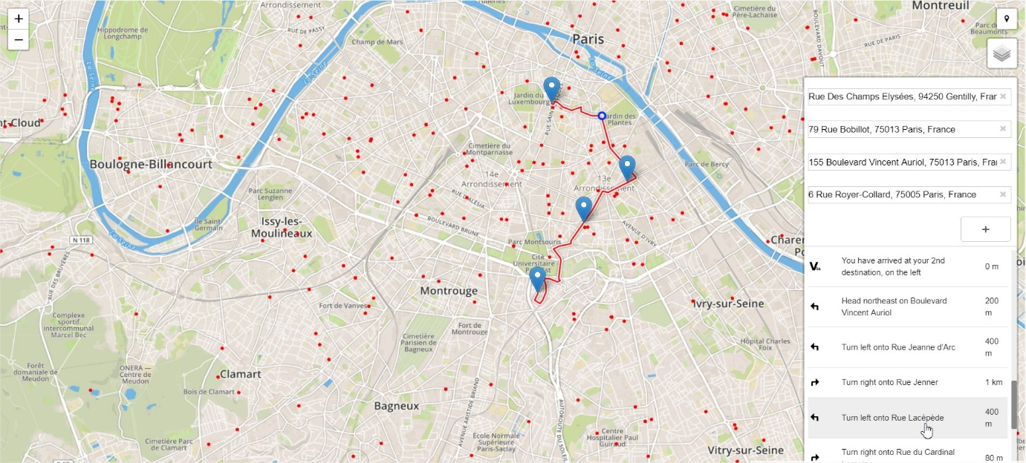

By clicking on the POI point of the chosen category, you can have some information on this POI (address, phone …):

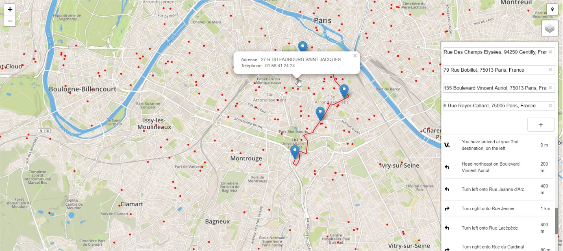

By clicking on the map, you can change the location of the start and end point:

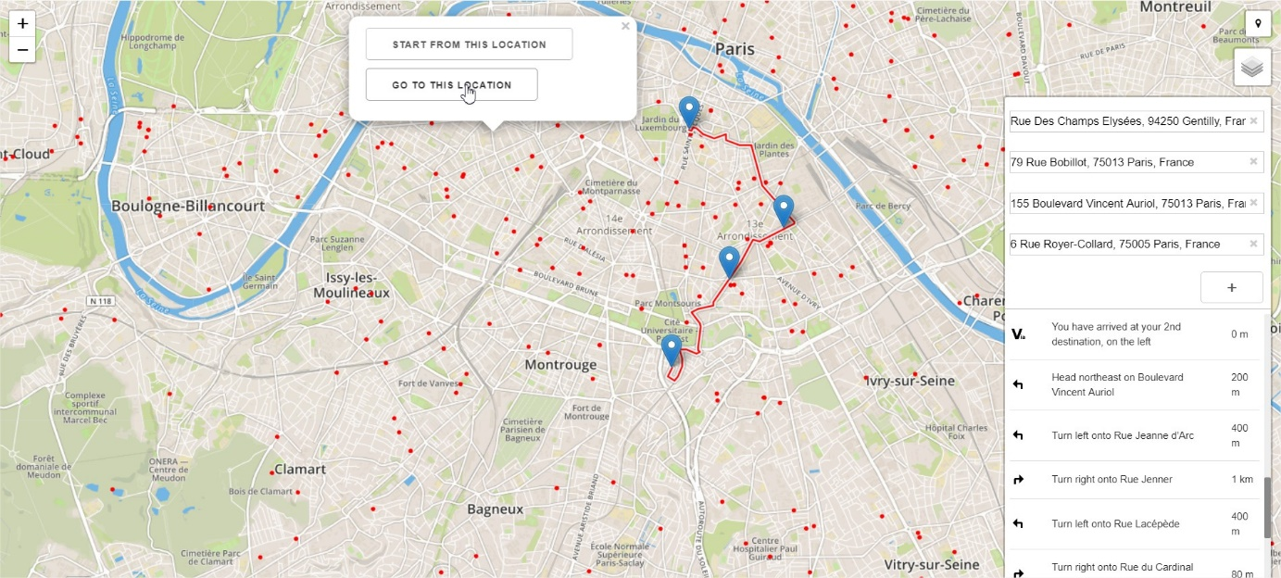

Also, Voice recognition features permits to speech the address wanted. You can choose between saying the start location, the destination or with a full sentence the complete route wanted : “Address1 direction Address2”

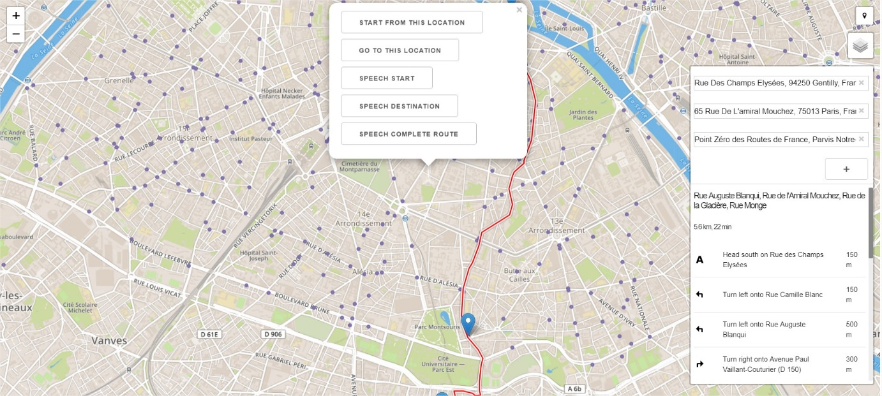

Finally, you can customize the appearance of the map:

